The Benefits of Hands-on Learning

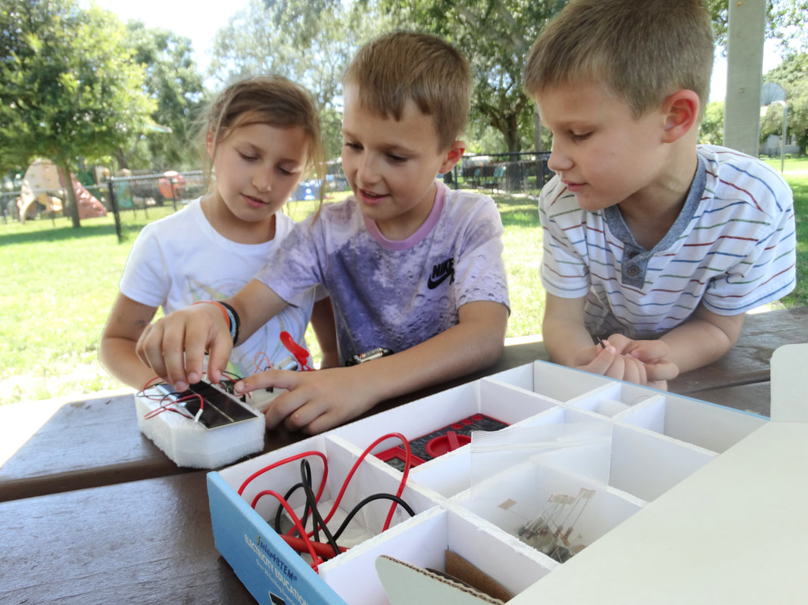
Interactive learning offers a myriad of benefits that hands-off approaches simply cannot rival.
For young minds, creativity and interaction are the cornerstones for successful development; how we reinforce these principles in our youth will stick with us for life. We learn through stimulating our brains; what better way to learn and grow then engaging multiple parts of our brains? Why not take up activities that activate the various parts of our brain in a critical and creative way? Interactive learning is the solution. The benefits of hands-on learning are plentiful and powerful. Here are just some of the many rewards offered:
Contextualizing learning in terms of the real world.
In classes, STEM classes especially, knowledge may not come naturally without seeing it in action. For example, science classes like physics which study the phenomena of the world around us are extremely difficult without any exposure or observance of the real-world processes. Our education is derived from the observations of the real world; thus, to truly maximize our learning, we must interact with it on a regular basis. Those who embrace the physical parts of education will retain a much greater understanding of the science, mathematics, engineering, and technological concepts which drive our world today.

Bridging the gap between work and academics.
Work and academics can vary greatly; while school may be contextualized through a series of reading, notetaking, and tests, employment is starkly different. Work is driven by interaction, by doing, by getting results, and being creative. The working experience is very similar to experimenting; learning by doing is a necessity in our society. Hands-on exercises are a powerful way to engage children in the environment of their future, instilling the early principles of work ethic leading to their success.
Keeping all types of students engaged.
Students have a variety of learning styles; among the most popular are visual, aural, and kinesthetic learners. Traditional classroom exercises may be only partially reaching students; a PowerPoint could only appeal to visual learners, a video to visual and aural learners, a boardgame to visual and kinesthetic learners, and so on. A collaborative approach through projects incorporate all types of learners through providing visual, audio, and physical stimuli, as experiments in nature highlight the co-existence of all three.
If you want to take advantage of these benefits and more, you need a STEM solution fit to your classroom. You want a STEM kit which reduces the hassle and preparation of experimenting and maximizes student learning and engagement. You need a solar4STEM kit. A solar4STEM kit engages students in the education of renewable energy, electricity, and solar power through promoting hands-on experiments in nature, appealing to all types of learners of all ages. With solar power technicians being among the quickest expanding U.S. job fields, an investment in a solar4STEM kit is a wise investment into the future.

Implementing Hands-On Learning at Home

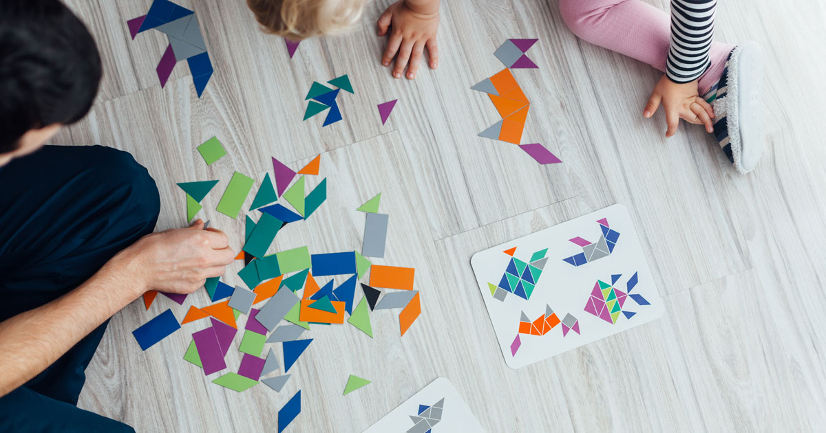
There are plenty of opportunities for interactive learning and teachable moments outside of school!
Experiments may seem as an old relic of classrooms once forgotten in the age of social distancing. When it comes to learning, many of us may think that education merely comes from a classroom; this simply is not true! The roots of learning come from the hands-on experiences we build from life, especially from home! In this time of isolation, it is important to continue thinking of interactive activities to keep ourselves busy as well as teach and develop ourselves. That may sound harder than it is, for there are plenty of resources and outlets to take advantage of the benefits of STEM learning right from the comfort of home!
Using toys to promote STEM learning:
Toys are a great way to promote the principles of STEM! Promoting physical activities through adventure, toys reinforce all the key points of STEM, as well as the principles of success in life. These points include critical thinking and discovery through adaptation, collaboration with others, creative invention of new games with toys, as well as a diverse and personal understanding of the world through the process of play.
Modifying DIY experiments:
There are plenty of do-it-yourself experiments on the internet that allow for hands-on interactivity. While you may not have the time or the materials to do all these experiments, why not tailor them to your needs and incorporate some outside of the box thinking? Taking activities from the internet and putting your own spin on it can be an exciting way to form ideas about the world and behavior of phenomenon through offering an element of discovery rather than performing an exercise that is preordained.

Exploring a world of discovery with STEM kits:
STEM kits are a perfect balance of learning and discovery; with ready made instructions and materials, they provide a quick and easy way to jump straight into the engaging world of experimenting. With a variety of materials at your disposal, you are free to mix and match to your heart’s content, discovering the various ways the world works right at your fingertips. STEM kits put you in charge of the learning while supplying the materials you need for hours on hours of hands-on learning. Whatever your interest, there likely exists a STEM kit perfect for you!
If you are interested in solar energy or electricity, solar4STEM is the STEM kit for you. With various exercises ranging from circuit creation to operating a fully-fledged solar panel unit, solar4STEM will retain the interests of all ages. With the variety of objects included in our kits, including products featuring a solar panel and solar power terminal, the possibilities for modification and adaptation are endless. Let CME help you take advantage of the benefits of hands-on learning in your household through solar4STEM!

Implementing Hands-On Learning in the Classroom

With the quick adoption of virtual classrooms, it may seem that hands-on activities have fallen by the wayside. The shift of classrooms from physical to virtual should not underscore the importance of hands-on activities; if anything, they have brought out the vitality of maintaining a sense of physical learning in a time of separation. For students in STEM classes, teaching in the natural world is the key way of communicating information to all types of learners; it is critical that teachers adopt the methods of hands-on activities in the online era towards their classrooms in order to gear their students for success! Luckily, there are plenty of creative ways to implement hands-on learning in your classroom.
Leveraging DIY resources:
A variety of educational and governmental entities have turned to posting a plethora of do-it-yourself STEM activities in this time of isolation. Many of these experiments can be done with staple goods! Organize an experiment based on one of these DIY activities and have students collaborate and share results! Use the digital platform to have students recording themselves performing the experiment for others to see; apply the different ways each student performs the experiment to have them mix and match, trying to reach the goal in different

paths to produce several new, insightful experiences that provide for several classes of learning and discovery!
Allow your students to design the experiment:
The pandemic has brought the issue of resources to many families; as a teacher, it is hard to ensure every student has the same opportunities. Posing a problem to your class and giving your students the liberty to design the experiment not only solves this problem but reinforces creative and critical thinking! This is a perfect solution to infuse project-based learning, and the values of teamwork, into your classroom.
Use a STEM kit to reinforce experimental design:
If you want to broaden the opportunities for all students while providing some structure and boundaries to your experimental design task, a STEM kit is what you need. With a uniform set of materials for all students and a set of included experiments, a kit provides plentiful self-study, hands-on opportunities bridging into a more independent mindset.
Introducing hands-on education into your classroom does not have to be difficult; if you want to reinvigorate your digital classroom with the necessary benefits of sensory activities, solar4STEM is an excellent option for renewable energy and electricity lessons. With dozens of included experiments, ranging in complexity, and a wide array of materials geared toward solar education, solar4STEM is perfect for any age range. Reintroduce the strengths of applied knowledge with CME to bolster student achievement!

What Learning Type are You?

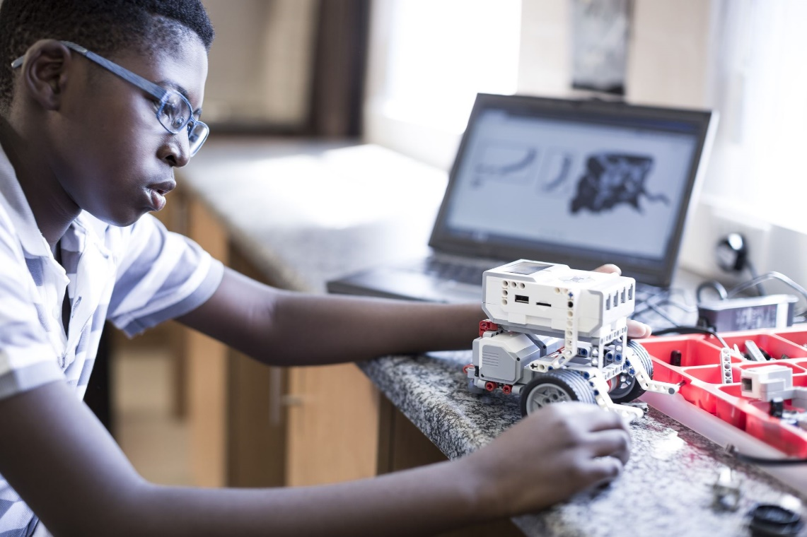
In many ways, we all are different; to truly master our own potentials, we must recognize our differences and harness their strengths – why should learning be any different? A learning type is just one of the many differences we all share; knowing and mastering your learning type could be the key to achieving success from the classroom to the real world! While there are a variety of learning styles, many can be organized into four main categories:
Visual Learners
These individuals learn best by observation. Visual learners prefer images, videos, and graphics to process information. In a digital age, visual information has become more prevalent than ever through PowerPoints, data organization through graphs and tables, social media, and so on. Demonstrations also do the trick here.
Auditory Learners
Listening and sound are the best reinforcement for those auditorily inclined. Those who are auditory learners prefer explanations above all else; a lecture is likely to be most effective here rather than reading off a document. Conversation and combining sounds into activities are critical to their success.
Kinesthetic Learners
For kinesthetic learners, doing is everything; when given the chance to work hands-on, they will gladly jump at the chance. Using all their senses in conjunction with the information given, this group of people need experimenting and interaction with the physical applications of ideas to gain a better grasp.

Reading/Writing Learners
Those who enjoy reading and writing likely fall into this category; they can analyze and express critical ideas through writing to gain a more thorough understanding of arguments and concepts. While many activities may inherently cater to this group, they will likely prefer written instructions during activities that are hands-on.
Quiz
Let’s find out your learning type!
- I find I am most interested in a subject when…
- I am experimenting or working with my hands.
- A video or film is being played.
- I am involved in a discussion or conversation.
- It is contained in a book or narrative.
- If I wanted to learn about robots…
- I would try building one myself.
- I would watch a video or show on how they work and how they are made.
- I would talk to others about it or listen to a podcast on it.
- I would read articles, guides, or technical writing online.
- To relax, I would turn to…
- Crafting, building, or a personal, hands-on project.
- A show, series, or movie.
- Music or a podcast.
- A book or writing out my thoughts.
- If you wanted to best get a point across to me…
- I would need to get my hands on it and try it for myself.
- I would need someone to show it to me.
- I would need to discuss it.
- I would need it in writing.
- The best way I would learn from a demonstration or experiment is…
- Through conducting it myself.
- Just by watching it.
- Having someone explain what is happening to me verbally.
- Reading the written procedure, steps, or report.
If most of your answers were ‘A’, you are a kinesthetic learner. If most were ‘B’, you are a visual learner. If most were ‘C’, you’re an auditory learner. If most were ‘D’, you’re a reading/writing learner. You may find there is no overwhelming majority; if so, that is fine! There is a broad spectra of learning styles; you could process information in a myriad of ways!
For both students and teachers, finding resources to complement your learning style may be tricky. Did you know CME’s solar4STEM can cater to all these learning types? Through harnessing the power of solar powered experiments in the natural world and combining that with classroom instruction, you can set up activities that allow for visual, auditory, physical, and written contexts. Let CME help you master your learning type!

What Teaching Style Fits You?

Not all classroom experiences are created equally; while the content and curriculum across classrooms in the United States, and even the world, may be nearly identical in some subjects, it’s the teacher that has the power to make a real difference in shaping young and innovative minds. A major part of how students, or others, respond to you as a teacher is your teaching style; do you know your teaching style? Knowing what type of teacher you are is important to truly harness your strengths toward certain subjects and content and adapting to other styles as needed. Teaching styles can be grouped into four categories:
Formal Authority
As the formal authority, you have all the power over your classroom. Teachers who are the formal authority often turn to lectures in delivering information; often, they are the only ones speaking and students are focused on receiving. Getting out content is the primary focus here.
Demonstrator/Modeler
The demonstrator/modeler is another type of teacher-centric instruction model for task mastery. The teacher’s job is to display how a process or task gets done, often in an experimental setting or a demonstration as an add-on to notes, so that students can master the task or make observations.

Facilitator
The facilitator is one of two student-centered teaching types; the teacher creates an exercise in which students will undertake individually or in groups. It is the responsibility of students to undertake the project; however, the teacher sets many of the parameters and guidelines. This rigid type of project-based work is great when focus is needed.
Delegator
A very similar style of teaching to the facilitator, the delegator’s focus is on student exploration and empowerment. Unlike the facilitator, the delegator sets little guidelines for a student-based project and merely acts as a consultant or counselor. This teaching style fosters creativity and collaboration.
Quiz
Let’s find out your teaching style! You can take the quiz here or below.
- I feel my students learn best when I…
- Lecture and thoroughly go through notes and presentations
- Work out problems with them or use experiments to demonstrate.
- Give them a project with a clearly defined goal.
- Let them freely explore the subject for themselves.
- My focus as a teacher would be…
- Delivering content in the most efficient way.
- Showing students tasks and processes and making sure they can master them.
- Letting my students show what they know through projects I control.
- Ensuring my students have plenty of room for creativity.
- If I were to teach my students about the importance of movies…
- I would lecture about the history and impact of film in American culture.
- I would demonstrate how a movie is made and its impacts using the class as a model.
- I would give my students a film project with a defined time and topic.
- I would give my students a film project with little constraints.
- If I am reviewing homework, my priority would be…
- Pointing out the common errors in a lecture before assigning homework.
- Working through the homework with my students.
- Asking for students to work through problems together I believe they might have trouble with.
- Letting the students tell me what problems they had and advising them on how to work through it.
- In designing a lesson about vocabulary, I would focus on…
- Creating a comprehensive PowerPoint on the vocabulary terms.
- Creating a story using the words and having my students learn through the story.
- Letting them write their own story from a preset of vocabulary terms.
- Letting the students create their own story based on their preference of vocabulary terms.
If most of your answers were ‘A’, you fall in the formal authority category. If most were ‘B’, you are a demonstrator/modeler. If most were ‘C’, you’re a facilitator. If most were ‘D’, you’re a delegator. You may find that there might not be an overwhelming majority and that is fine! Having a mix of teaching styles makes your classroom more adaptive to student needs.
Looking to improve learning in your classroom? Why not use a solar4STEM science kit? A solar4STEM science kit appeals to all types of teachers; with thoroughly written instructions for teachers and students, you could

design experiments in either a teacher or student centric approach! We can help you bolster your teaching method and deliver results in terms of student success!
Source: http://www.kvccdocs.com/online-certification/content/L-13/lesson.html

Three Hands-on DIY solar4STEM Experiments to Enjoy!

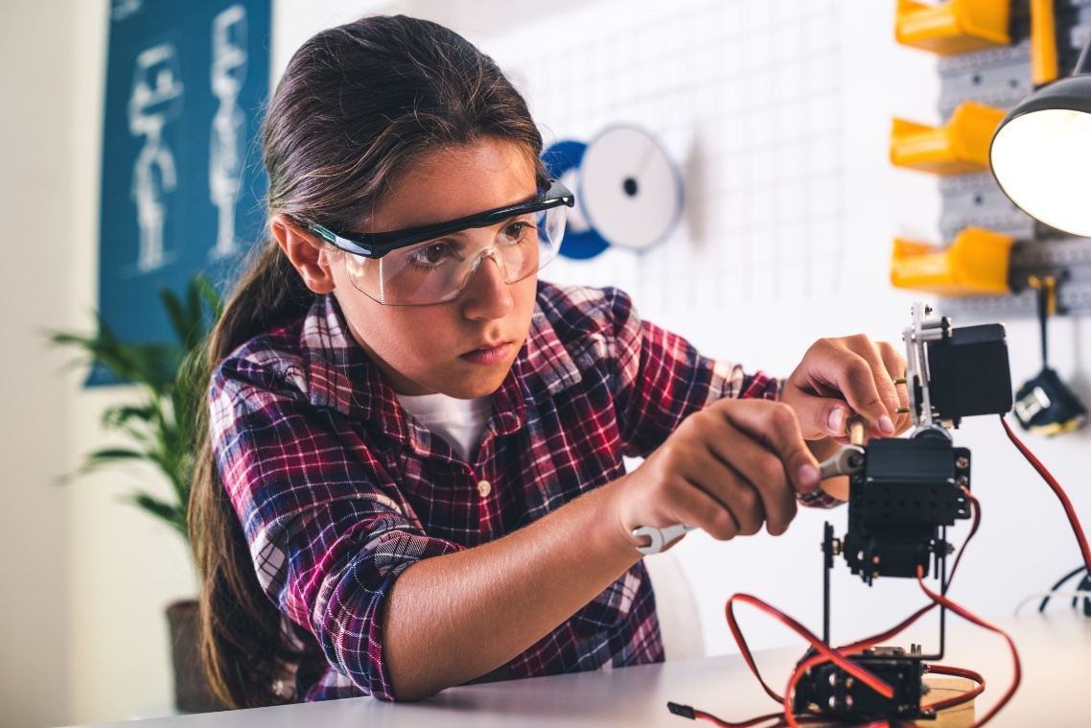
Experiments are a perfect way to expand your mind to the concepts of STEM and the physical world; while we may be stuck indoors, there are still ways you can harness the power of light to learn about the concepts of natural phenomena like solar energy! Here are three experiments you can do yourself at home with the same set of materials for the whole family to enjoy, derived from CME’s very own solar4STEM science kits!

Materials for Experiments
These materials can be reused for all these experiments:
- Solar panel (of any size)
- Digital Multimeter
- Light source (e.g. desk lamp)
- Breadboard (or soldering tools)

1 – Varying Light Intensities on a Solar Panel
Solar energy works by capturing photons and turning them into electricity; what do you predict will happen when the intensity of light, or the amount of photons, changes? Is there a limit to the efficiency of a solar panel?
- Plug the black test lead into the bottom socket of the Digital MultiMeter and the red test lead into the middle socket of the Digital MultiMeter
- Move the Dial on the Digital MultiMeter to the 20 in the DCV region. Touch the ends of the black and red test leads to make sure the voltage on the Digital MultiMeter Reads 00.0

- Take the black wire of one solar panel and the red wire of the other solar panel and connect them in the same row on the breadboard.
- Take the digital multimeter and touch the red test lead to the remaining red wire of the solar panels and the black test lead to the remaining black wire. Read the voltage of the solar panels in series.
- Shine a Desk Lamp on the Solar Panel and observe how the voltage changes as you move the lamp closer and further from the Solar Panel.

2 – Optimum Orientation of a Solar Panel
Solar panels work through the photoelectric effect, where photons collide and dislodge electrons located in the solar cell. What were to happen if we adjusted the orientation of the solar panel? Is there an ideal angle which allows photons to collide with the solar panel to eject the most electrons?
- Repeat steps 1-4 of experiment 1.
- Shine a Desk Lamp on the Solar Panel and observe the voltage.
- Change the angle of the solar panel by rotating it and observe how the voltage changes. Slowly adjust and make observations about which angle provides the highest reading to obtain the optimal orientation.

3 – Temperature Affecting Energy Collection
Photons kick electrons out of their existing energy states to produce a current; this difference from initial to final energies gives us electricity. Temperature is the measure of average kinetic energy; if we were to raise the temperature, what would happen to the electron’s initial energy? If the energy provided by the photon were to not change, what would happen to the overall energy collection? Follow these steps to find out:
- Repeat steps 1-4 of experiment 1.
- Shine a Desk Lamp on the Solar Panel and observe the voltage.
- Keep the solar panel under the Desk Lamp for an extended period. The panel will begin to heat up. Record the voltage and current over time.
- Use the formula, power is equal to voltage times current to calculate the power over time.

With these three experiments, you can bring the world of solar energy right into your home! If you’re looking for a world of many more STEM experiments, choose CME and solar4STEM as the best choice for your science solutions.

Remote Experimenting in Science Classrooms

Large educational organizations like College Board have taken instructor experiments online for classes like physics, allowing students to interact in real time through social media.
Experiments are the core of science class. In the subjects of physics, chemistry, and biology, its important to provide the physical extensions to learning that bring theoretical concepts to life. However, as schools close across the nation and as social distancing takes effect, the world of education – among just about everything – has changed. Experiments are somewhat unthinkable without an in-person or physical setting. Being apart should not stop us from expanding our learning through experiments though; educators across the United States are using technology to bring experimental learning into the households of students.
How educators are adapting:
On the larger scale, the College Board is turning to YouTube livestreams in addition with Twitter feeds to host experimental learning with student input. A specific lesson would have been chosen for the day – angular momentum, circular motion, etc. – and one of several instructors will either do the experiment live or discuss pre-recorded footage of the experiment. All the while, they are answering questions from students as they come in on the Twitter feed.
Such learning is also quite feasible on a small scale; through Microsoft Teams and Zoom, teachers can accomplish the same thing if not to even greater degrees of success. The freedom a small classroom offers

means students can directly converse with the teacher using voice services during the experiment or utilize a text chat option. The great degree of flexibility entails that teachers can continue experimenting remotely with many of the benefits of an actual class; rather than physically manipulate instruments themselves, students can still offer live reactions and even direct the course the experiment will take, viewing the results in real time.
How you can adapt to remote experimenting:
You can use the various resources that technology and the internet have to offer to adapt remote learning for success in your environment or institution. By devising your own experiments or lesson plans, you can have live discussions with your students about their ideas, reactions, and interpretations of the concepts behind what is happening; you can even have them take the experiment in new directions!
To truly maximize your socially distanced experimental learning, you need to maximize the time for discussion and discovery; one way to do that is by reducing the hassle of preparation work. How can you maximize your time while also maximizing your quality? A STEM kit can help you. CME’s solar4STEM kits offer a variety of scientific experiment that are straightforward to conduct and provide a variety of learning for all ages. Specialized to your content needs, we can help you bolster your scientific teaching through hosting successful remote experiments!

How Teachers Can Use STEM Kits for Remote Classes

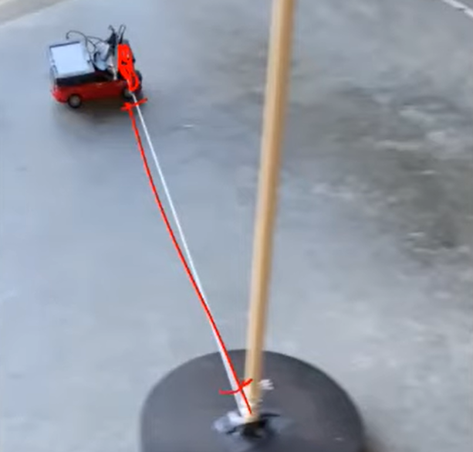
A simple experiment shown above with a toy car in circular motion around a pole by a string can easily be accomplished with the help of various materials found in a STEM kit! (The College Board)
Remote experiments provide the opportunity to present the physical aspects of science classes in the homes of all your students. Through either live or prerecorded demonstrations, educators just like you are expanding student learning and mindsets while keeping them engaged and excited about learning science. However, devising these experiments in a way that works for everyone digitally creates more challenges than that of traditional, in-person interaction. Fear not! With a STEM kit, you can solve a lot of the hassles of adapting to a digital platform while providing a high-quality education to your students.
How STEM kits tackle the new challenges of online learning:
We know that in these unique times, you need to devise unique solutions that keep learning going as if nothing ever happened. Times like these require reinvention; some of your already premade experiments may not work well in an online setting. This causes you to go back to the drawing board and redevise experiments from scratch, using up valuable hours for interaction with your students and a much-needed reinforcement the curriculum when not able to be in person. Moreover, a lot of these exercise may require additional preparation work for adaptation to an online setting; directions or procedures that may seem obvious in person may have to be more thoroughly explained or executed for your students to get a grasp of it over video.
A STEM kit eliminates the majority of these problems; with a prepared set of materials as well as a variety of included experiments from the instant you open the box, you reclaim many of the hours once lost to preparation or adaptation. Moreover, you gain quality; with the contents of the kit tested and at peak performance, you can rest assured everything will run at its best come recording time. In addition, the pre-written instructions add a level of uniformity and order to your experiment; just simply share the instructions online with your students! Finally, a STEM kit will add a level of discovery to your science classroom! By putting away the hassles of prep-work you can save time for the action and rejuvenate your curriculum with new content; you and your students can tackle dozens of new lessons together in a way that truly promotes the collaborative nature of STEM!

If you’re looking for a STEM kit, you should look for one that maximizes all of the benefits above; a CME solar4STEM product is what you need. With premium design to suit any needs you may have in these unique times, let CME help you maximize the power of the remote learning experience!

Enjoying Social Distancing with STEM Toys and Kits

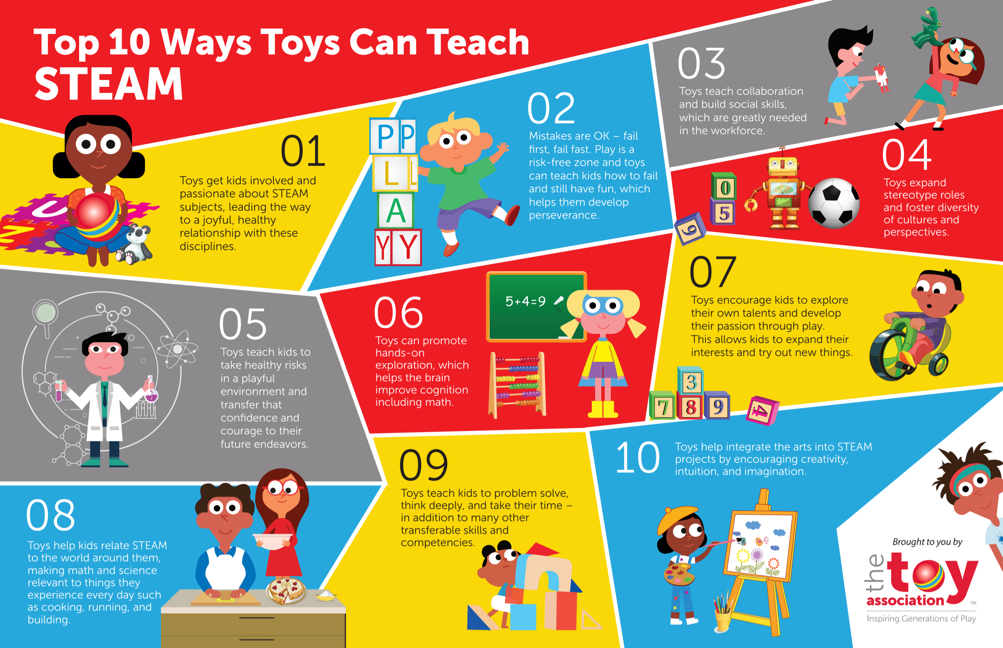

Toys and kits are an important part of STEAM learning; while at home, they are an activity you should not ignore!
Being stuck at home may feel like there is a lack of activities around you. For you or your children, sitting inside leaves a lot of energy trapped within us. Is there a way to maintain social distancing while finding a constructive outlet for that energy? Yes! The wonderful world of STEM toys and kits can help you and your child find fun activities to do while developing many other skills to use throughout life!
How science and STEM kits channel the benefits of STEAM learning:
All toys have the capacity to give your child the benefit of STEAM learning, but only some truly take advantage of all of these benefits. STEM kits make sure to maximize this experience by providing a product tailored to your child’s discovery of phenomena in the real world by play. Empowering their discovery, a STEM kit should make it easy, convenient, and engaging to experiment to their heart’s desire! The benefits of STEM kits toward STEAM learning are not restricted to certain ages either! There are more advanced STEM kits for offering that provide learning experiences for children and adults alike!

Reinforcing social distancing with STEM activities:
STEM kits will help you and your child social distance by encouraging a world of self-discovery! While it may be more fun to play with friends, STEM kits encourage your child to interact with the science kit on their own; it can be a one-person adventure or with the help of a parent! Moreover, a STEM kit includes everything you need to get started on activities – this prevents the hassle of having to venture out for materials that may be scarce and breaking social distancing. Kits that provide a variety of experiments and questions are especially good for both social distancing and benefiting your child by keeping them engaged for a longer time; these give the user a challenge by not only setting goals, but also expands upon these goals by putting new spins on the objective. Most importantly, a kit has a variety of things in it – use this to your advantage! Opposed to one toy, think of a science kit of consisting of a variety of toys that can be mish-mashed in any which way! This makes every experience different with a lot of possible combinations, bringing joy and a lot of fun experiences that should get you through social distancing!
CME’s solar4STEM product line is an example of great science kits your child can play and learn with while maintaining social distancing! With a variety of levels for discovery that includes kids and adults alike, ranging from building your own solar car, to electricity kits, and even maintaining your own solar panels, we have the quality kits you need to make the best of social distancing!

STEM Tips and Resources For Parents

There are plenty of resources for parents to help their families get engaged in science activities! (Getty Images | doble-d)
In a time where schools are closed indefinitely, differing throughout parts of the nation, parents and students may miss the comforts of school; while a vacation from school may seem fun for a while, a lot of children may miss the interactions they have with their peers, or the activities they do in their favorite classes. Chances may be that your child is missing the experiments as a part of their science classes. Experiments offer outlets of discovery that give your child the joy of adventure and achievement! Even though schools are closed, and distancing is in effect, there are plenty of ways you can bring the wonders of STEM into your home and encourage your child to engage with experiments.
Two common resources for STEM learning:
Online do-it-yourself resources.
There are many sites that specialize in cranking out do-it-yourself resources for STEM experiments. With follow along instructions, they can provide much needed variety in times with nothing to do. However, in a time of isolation, you might not have all the necessary resources to do these experiments; in addition, if you are working from home or occupied with more pressing matters, the time commitment with some of these experiments may not be as appealing to you.
STEM experiment kits.

While STEM experiment kits come at a cost, they save you time and the hassle of assembling resources, experiments, and prep work. Including a variety of materials, STEM kits encourage you and your child to discover beyond the instructions of the experiment. A STEM kit may be just what you need to provide an engaging science experience for the whole family!
Tips for creating an engaging experience with STEM:
Take failures positively and encourage doing the experiment in a new way.
Science is all about making predictions; the whole point of experiments is seeing if our predictions are right or wrong. If our predictions were never wrong, or we were afraid to fail a few times, science simply would not exist as we know it! Many of the greatest discoveries in science come from failures or unintended discoveries. Do not be afraid to put your own spin on the experiment!
Provide a hands-on opportunity enriching for everyone.
With limited materials, it may be hard to ensure everyone gets a hands-on experience; for some, watching is not as effective of a learning tool as the physical experience. Make sure you’re picking a science kit or DIY experiment that involves everyone in the learning experience; after all, STEM learning emphasizes teamwork and is a great group learning and bonding opportunity!
If you want to keep your family engaged and experimenting while at home, you should invest in a STEM kit that emphasizes all the positives of learning. CME’s solar4STEM kit is a tool that reduces the hassle of prep work, provides enough materials for a collaborative and innovative setting, and provides lesson plans that not only outline experiments, but offers exploration and alternatives to learn your way. Let us help you bring the wonders of a science classroom into your home!

